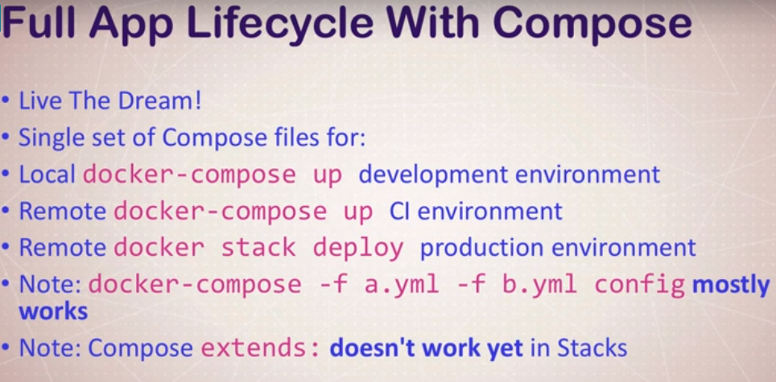

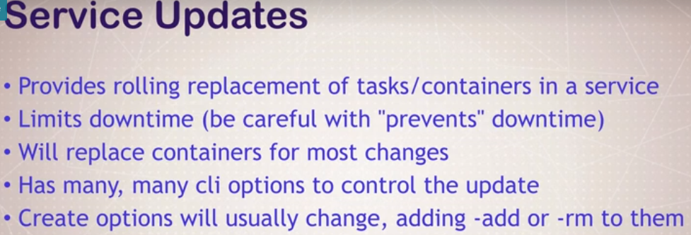



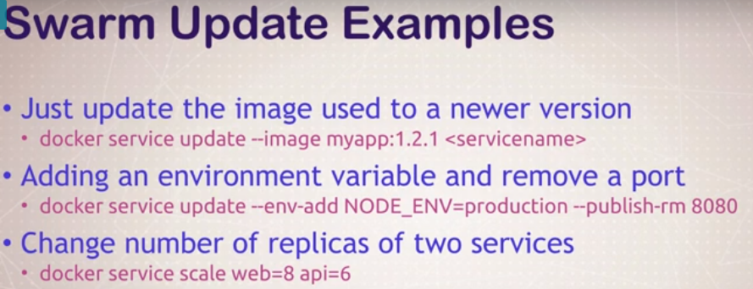

docker service create -p 8088:80 --name web nginx:1.13.7

docker service scale web=5

docker service update –image nginx:1.13.6 web

docker service update –publish-rm 8088 –publish-add 9090:80

docker service update –force web

docker service rm web





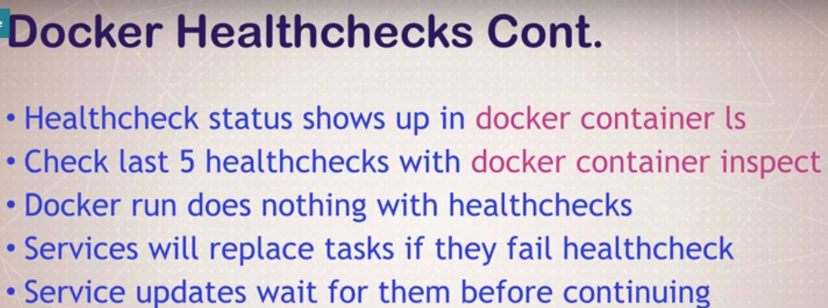









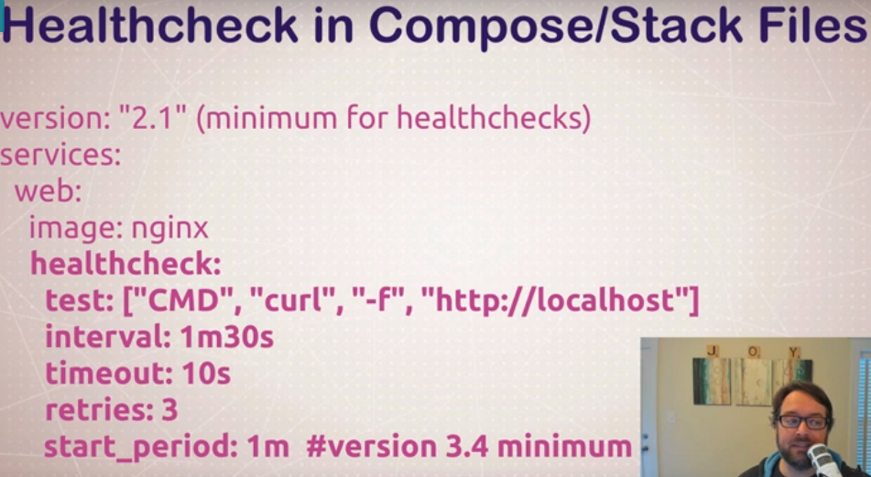

docker container run –name p1 -d postgres

docker container run –name p2 -d –health-cmd=”pg_isready -U postgres || exit 1” postgres

docker service create –name p1 -d postgres

docker service create –name p2 -d –health-cmd=”pg_isready -U postgres || exit 1” postgres